CC1 NAME: MEAGA J

727721EUIT088

QUESTION 1

Instance in the us-east-1 region with the following requirements. Give the Name tag of both EC2 instance & keypair as "ec2usecase1"(Name) . (4 Marks)

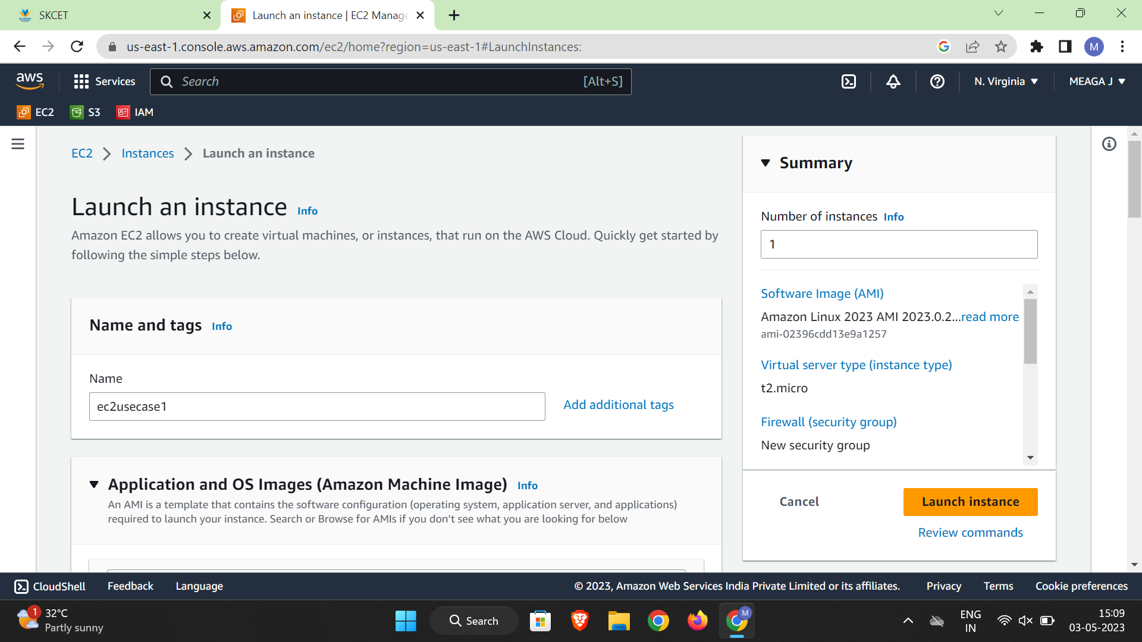

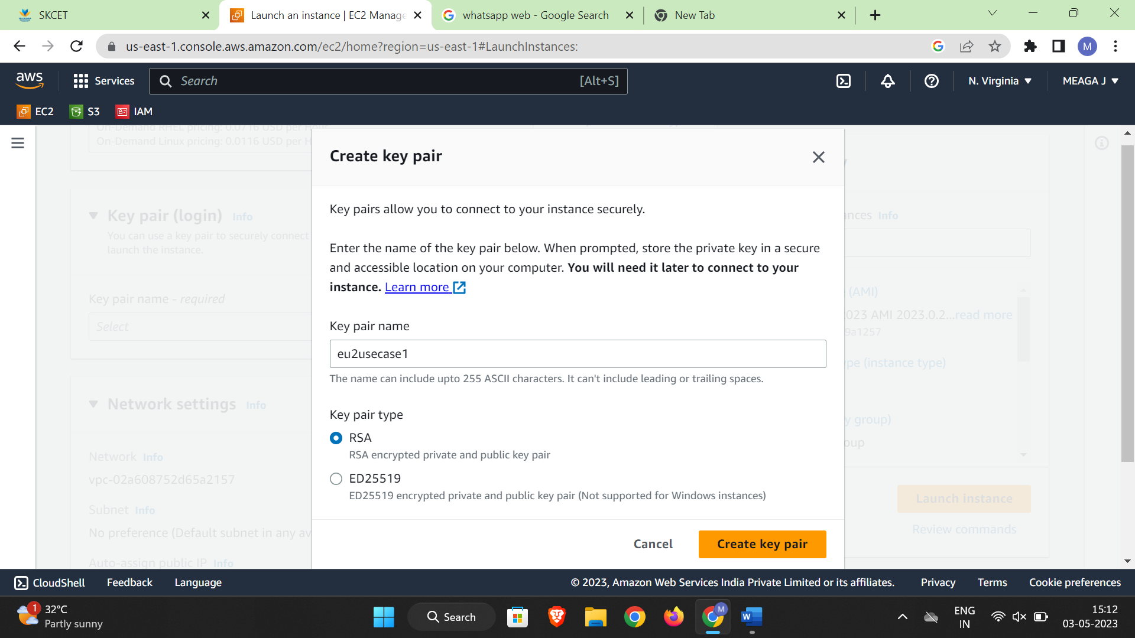

EC2 instance AMI should be "Amazon Linux 2".(4 Marks) 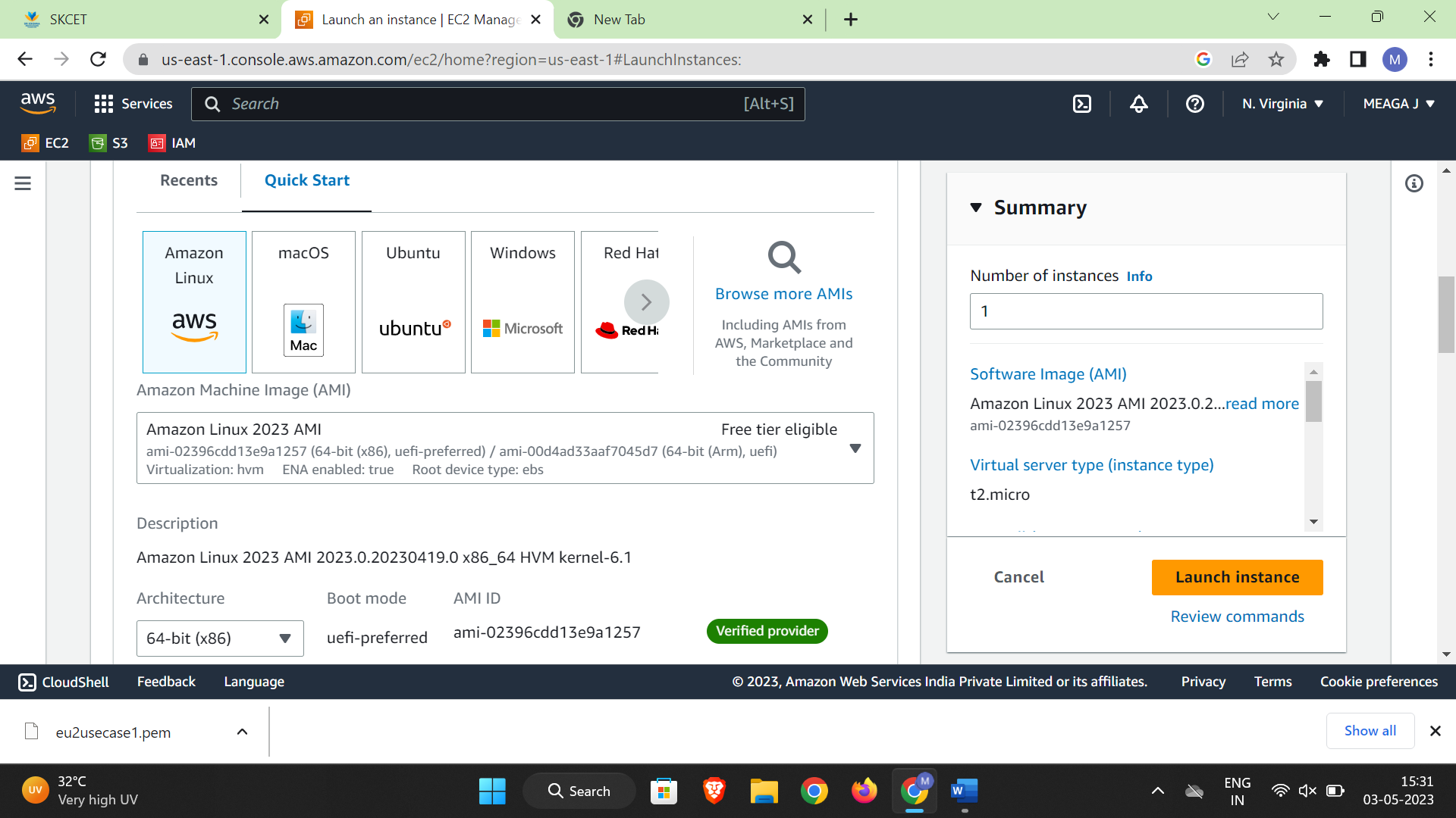

ALLOW SSH TRAFFIC

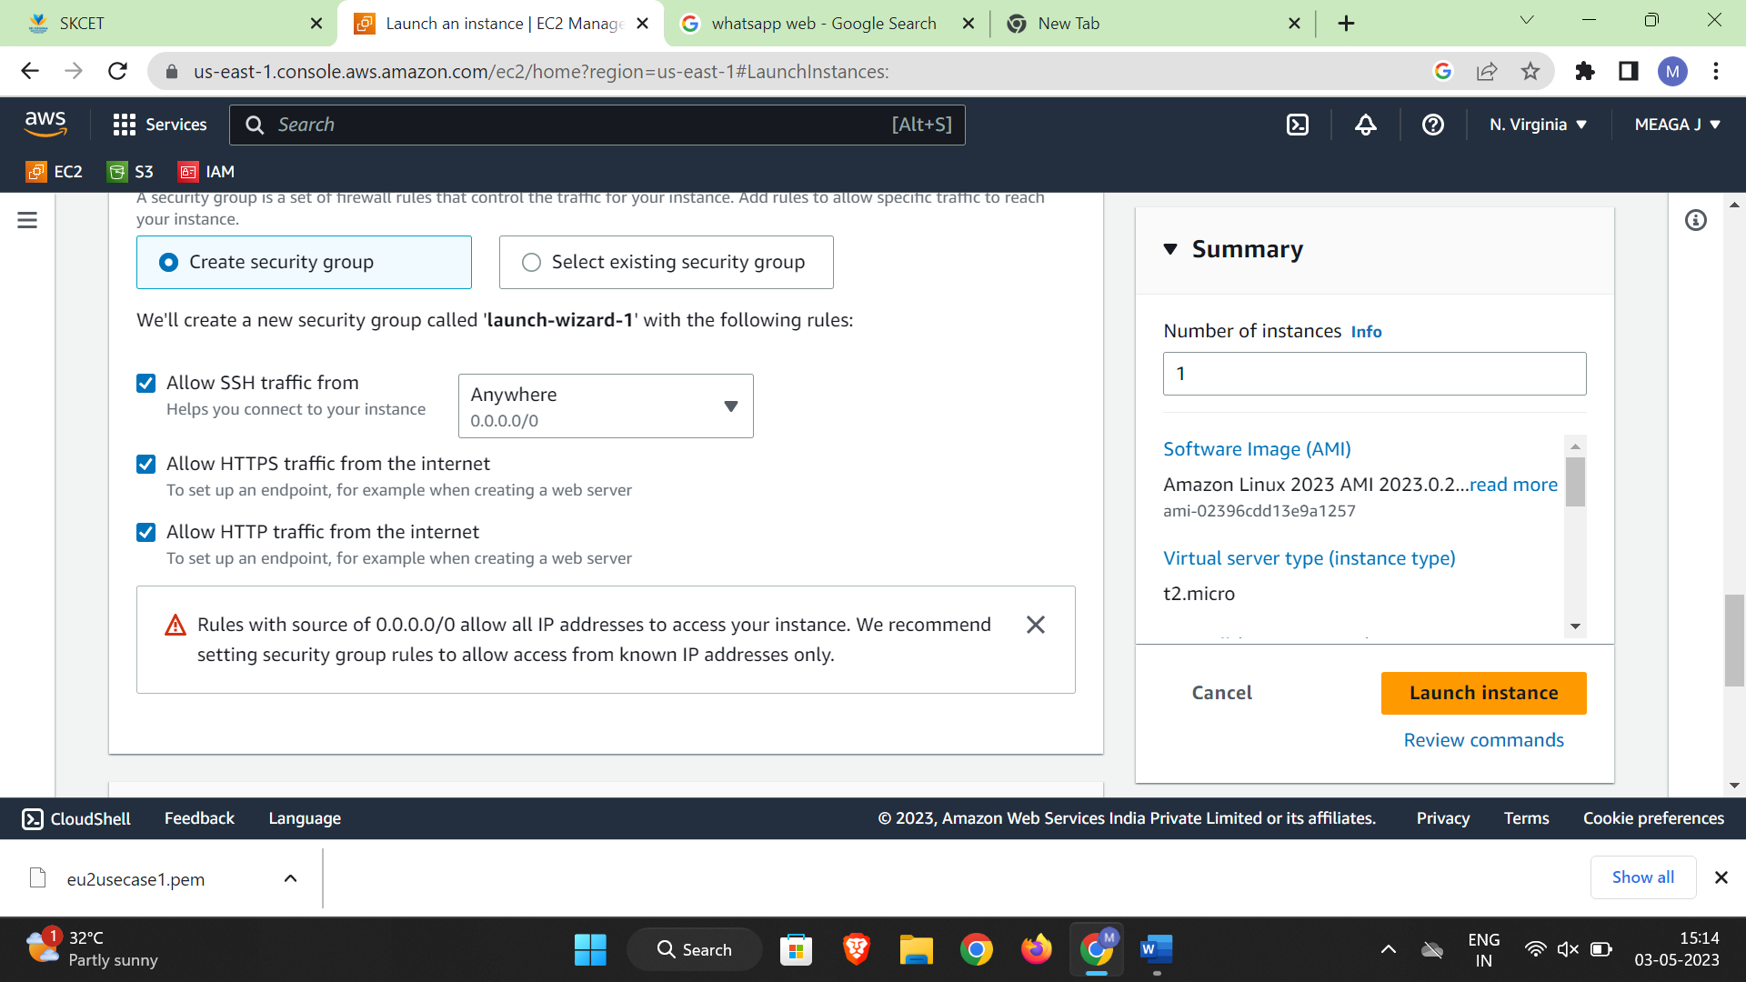

ALLOW HTTP TRAFFIC

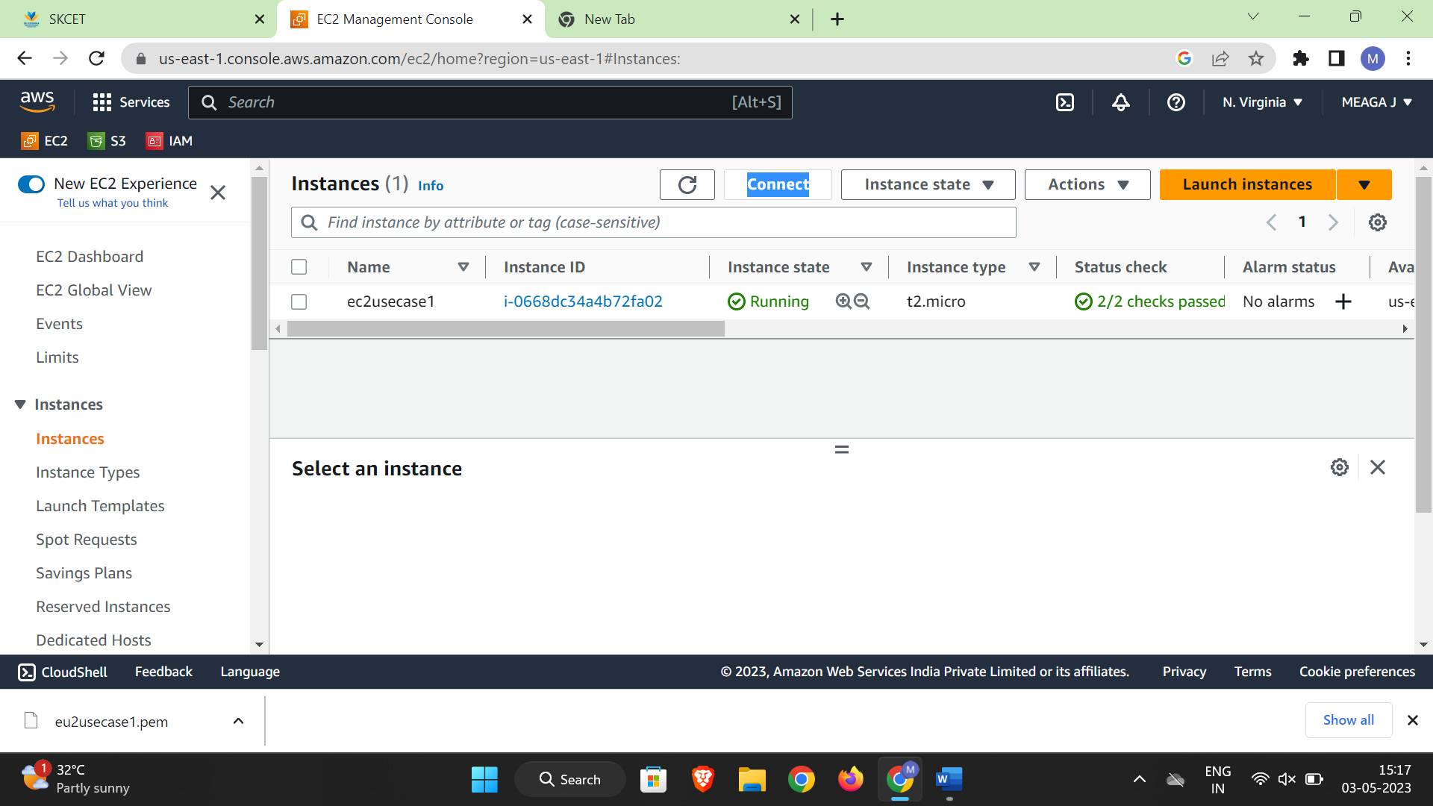

QUESTION2:

1.IAM GROUP(4 marks)

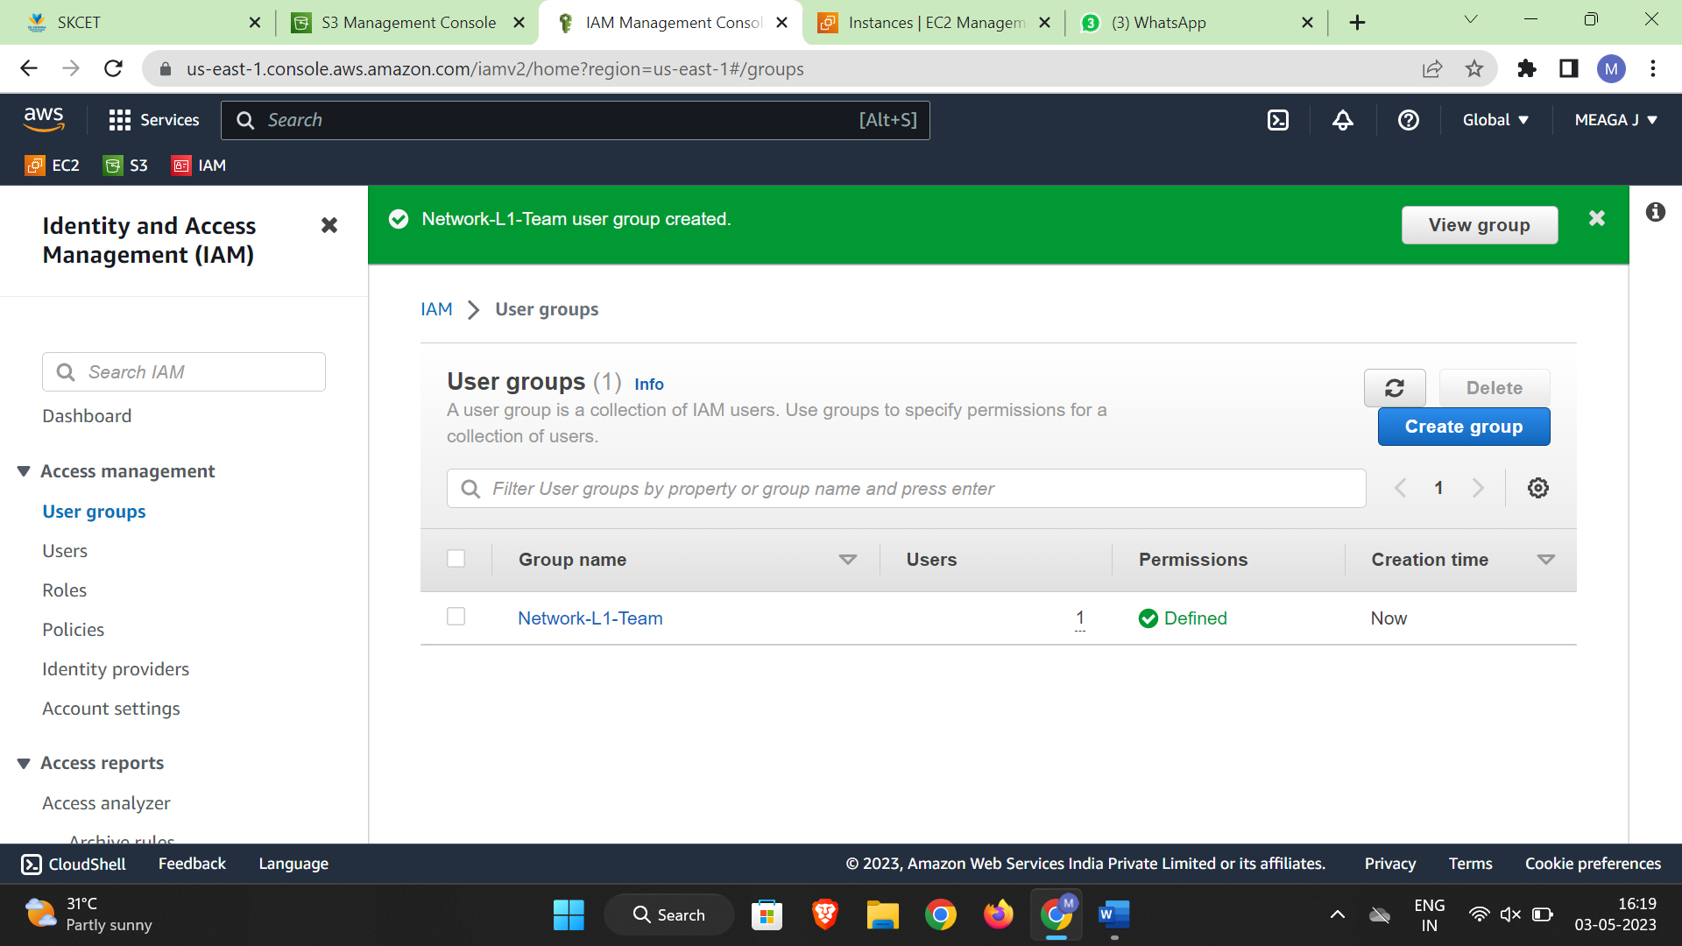

2.IAM USER(4 marks)

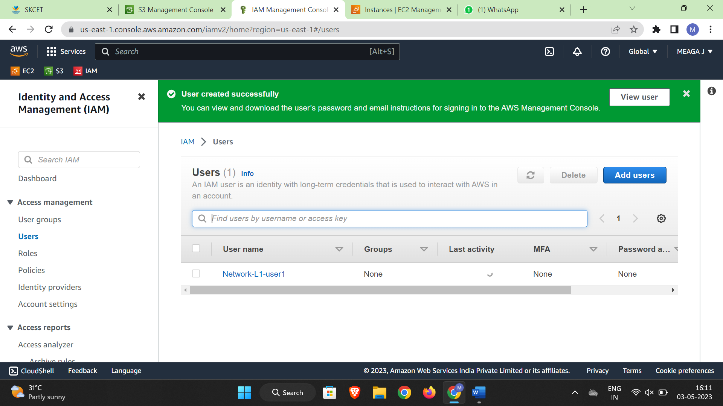

3.AMAZON VPC READ ONLY ACCESS(4 marks)

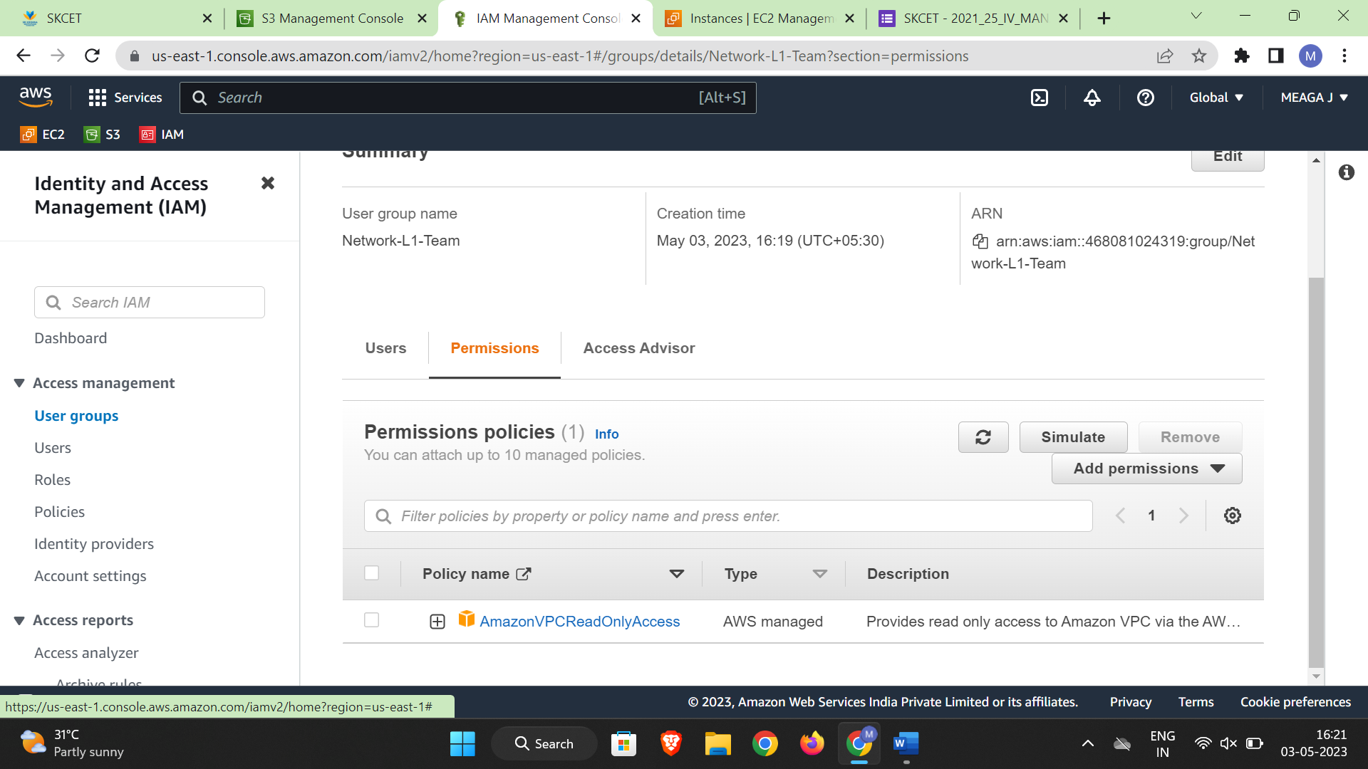

4.AWS NETWORK MANAGER READ ONLY ACCESS(5 marks)



QUESTION 3

Region of stoclkholm.(4 marks).

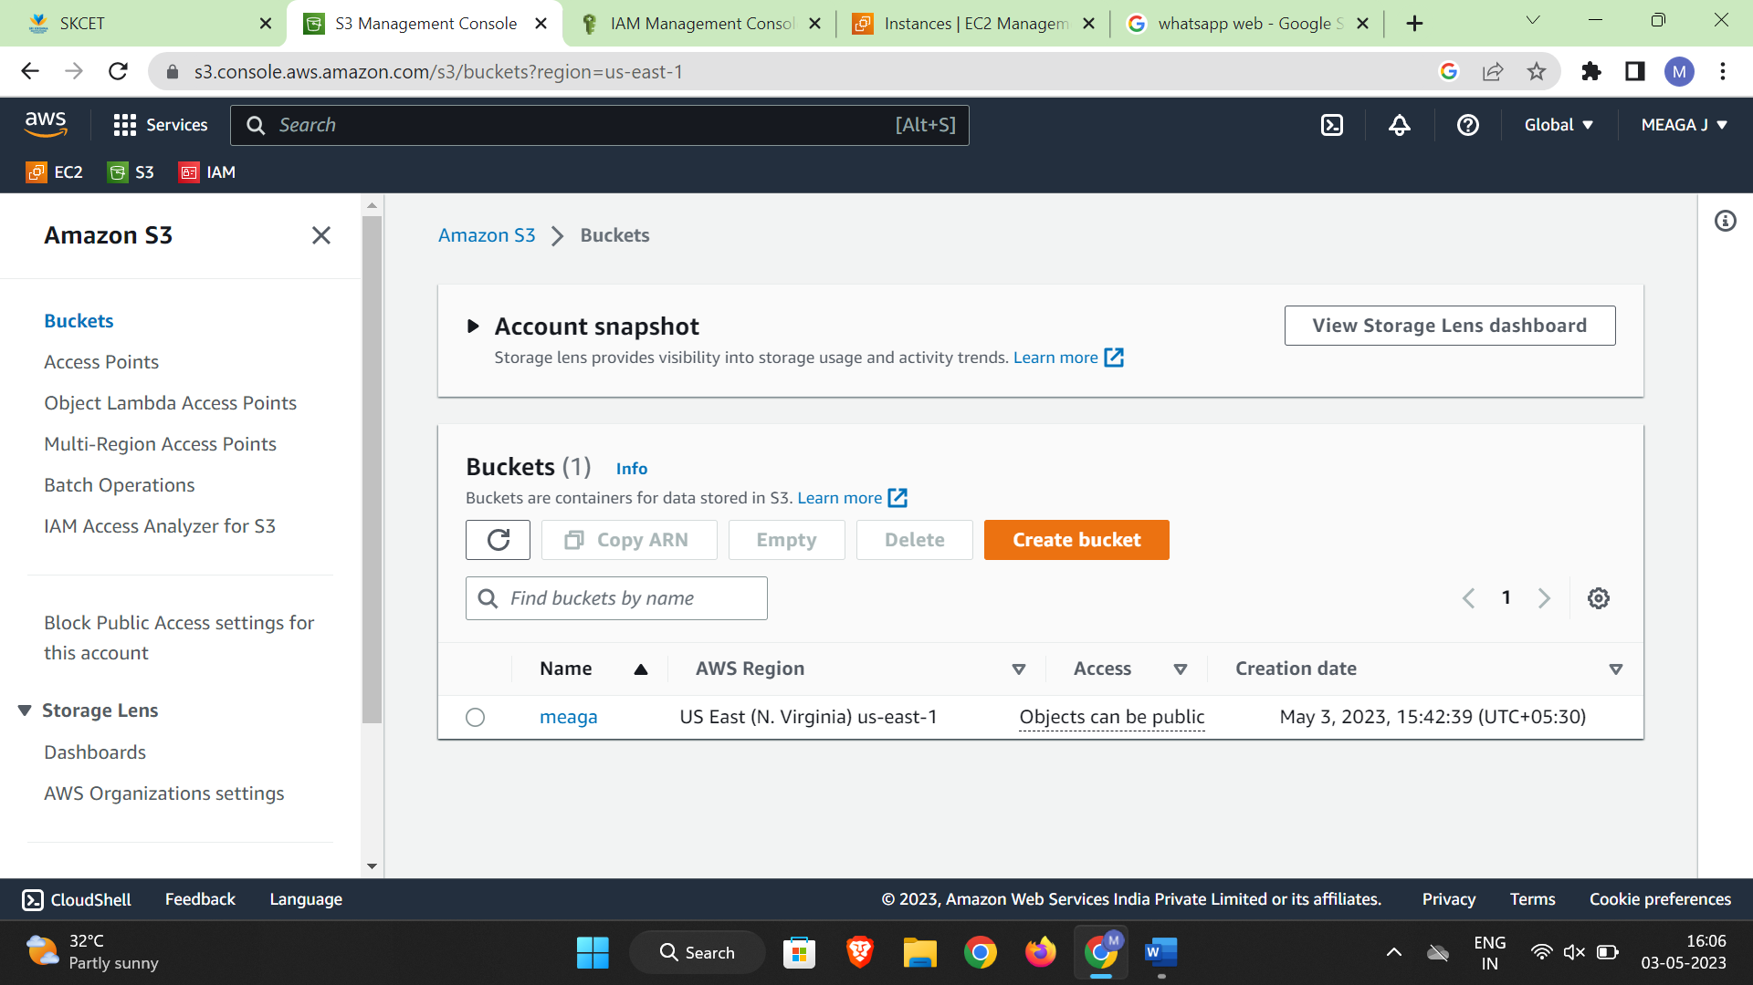

MAKE THE BUCKET ACESSBILE TO EVERYONE(PUBLICLY) 4marks

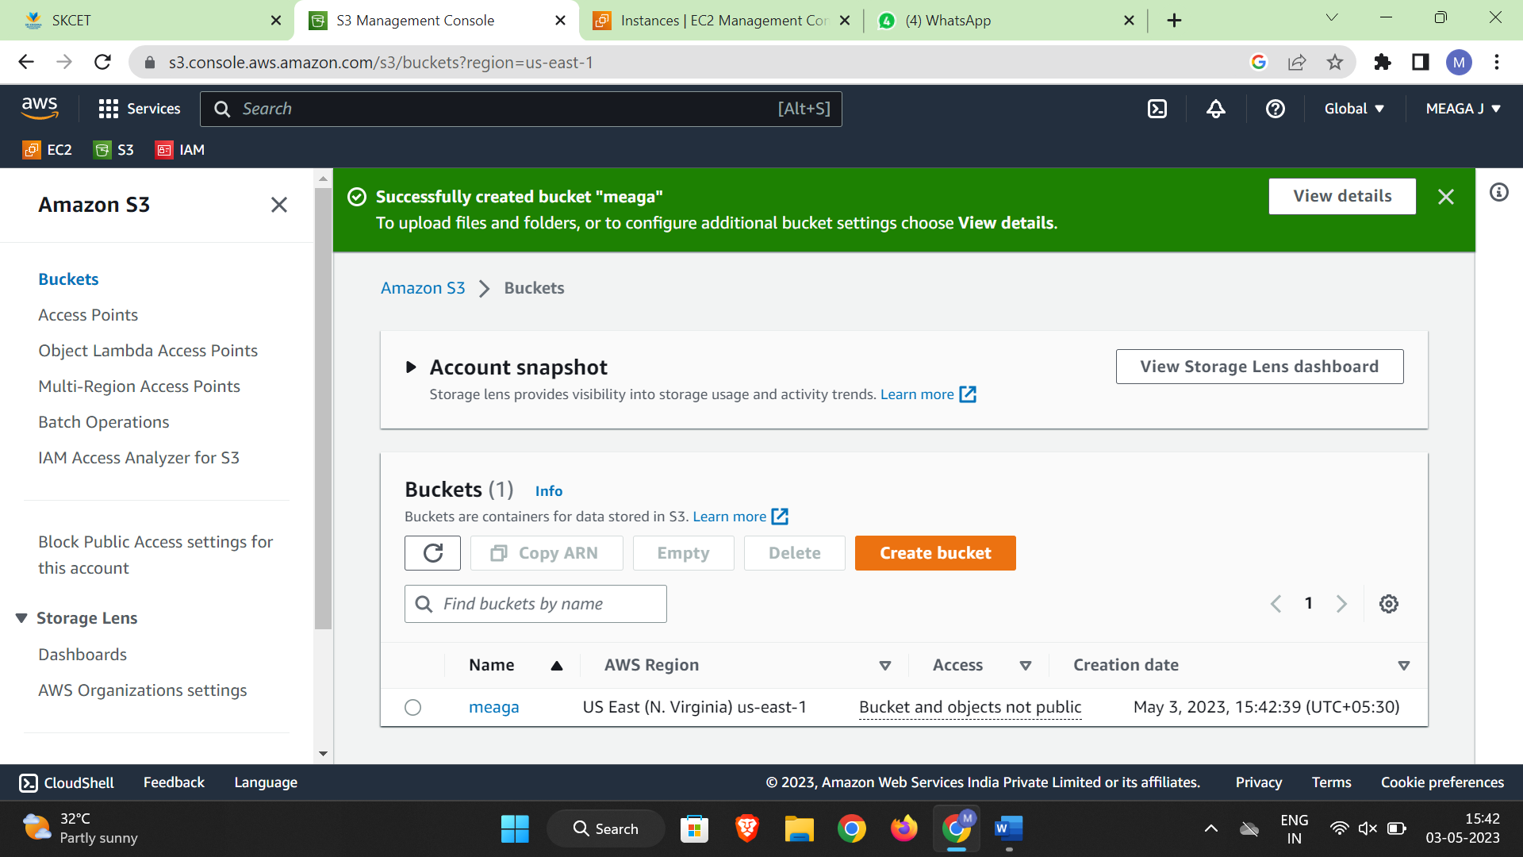

UPLOAD FILE NAME OF ‘Accounts.txt’.(5 marks)

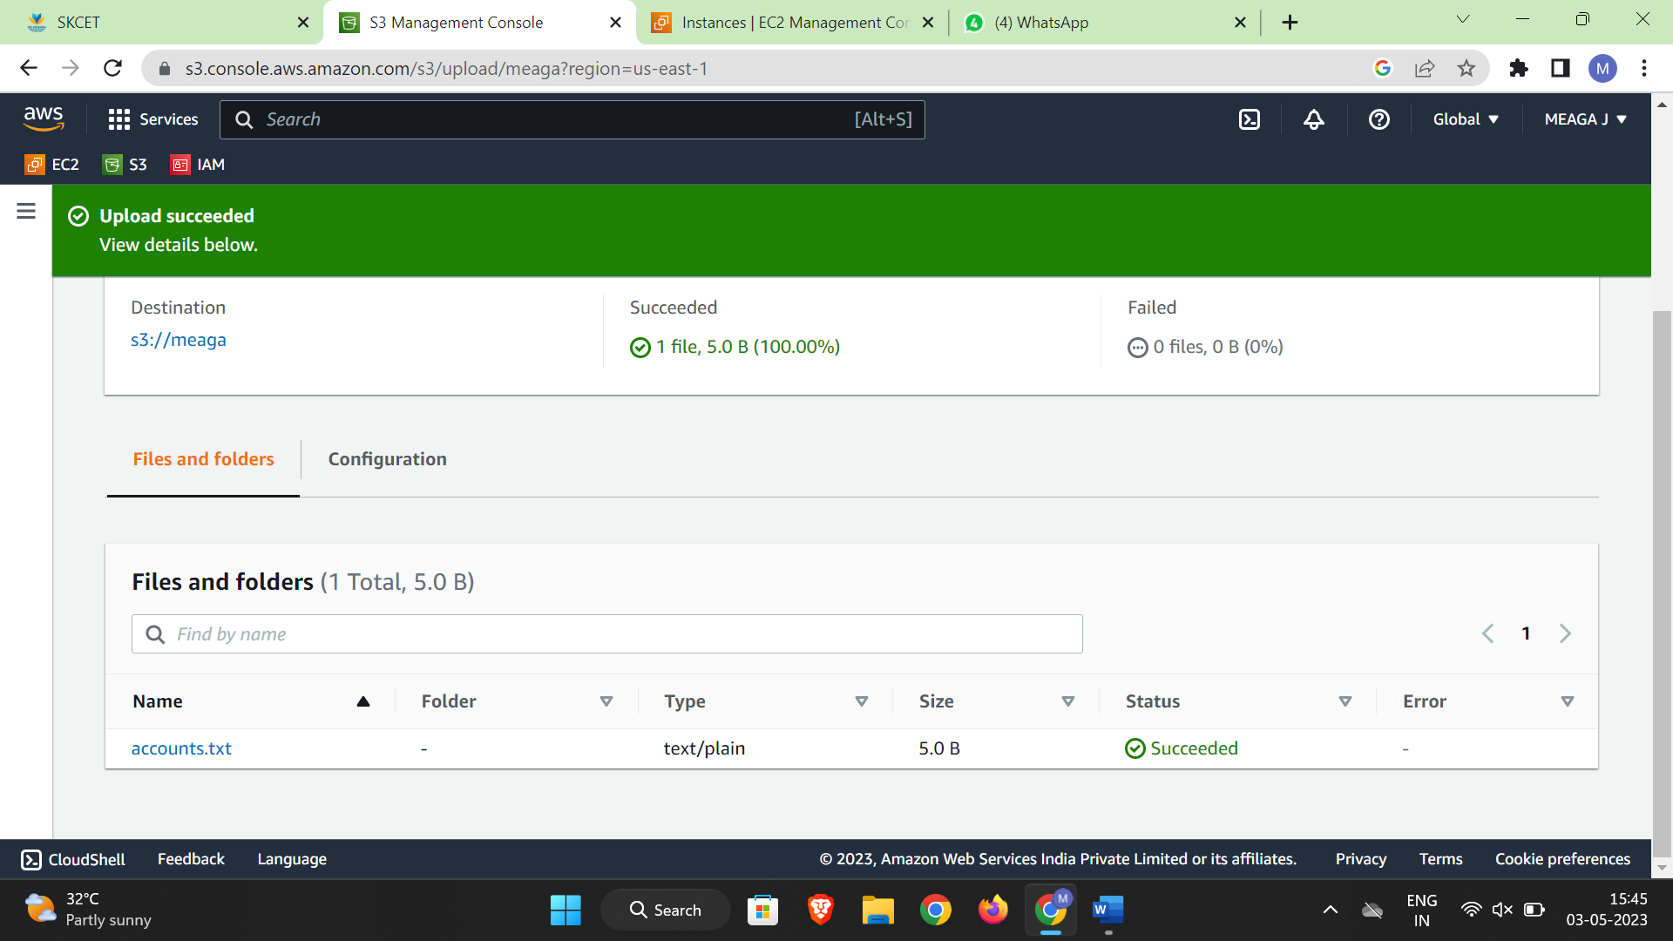

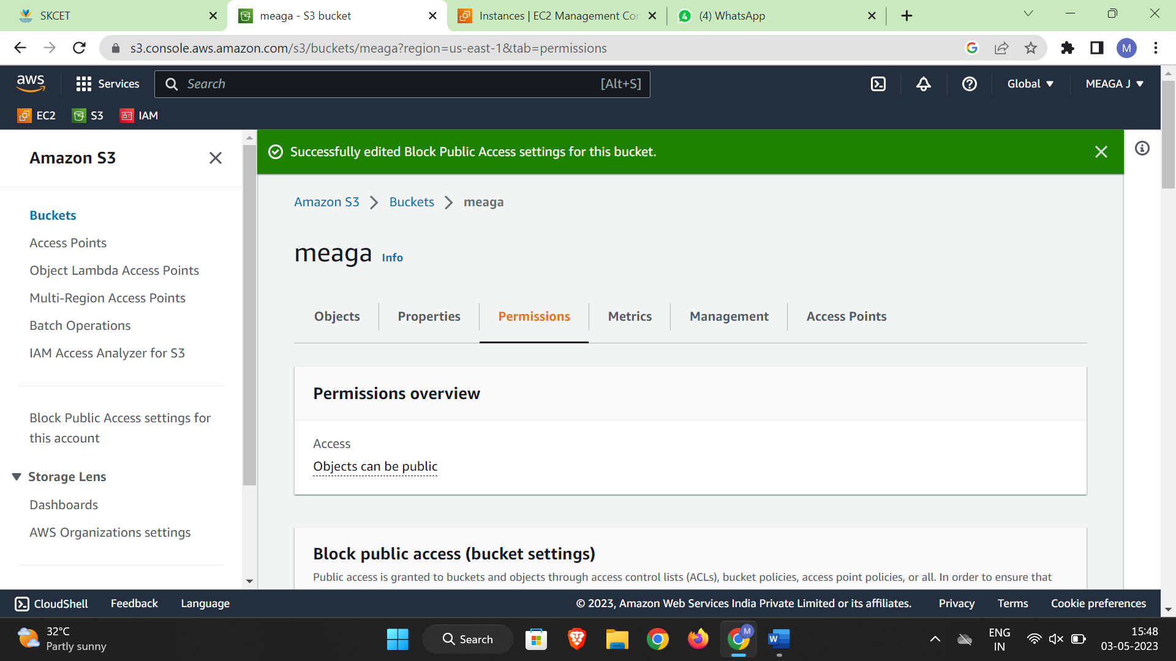

Make the object ‘accounts.txt’file accessible to everyone (publicly) 4marks.

